**Attachment Style and**    
**Uses of Music**

Submitted by John Downing, Irene Volpe and Jessica Verschoyle in partial fulfillment (and possible misunderstanding) of the requirements for IS53048A Assignment 2.

**Research Question**

To what extent is there a relationship between attachment style and uses of music?

**Background / Motivation**

Music is widely recognised as "a ubiquitous aspect of all human cultures [which] has been associated with broad psychological functions, in particular emotion regulation and coping" (Mikulincer & Shaver, 2010; p.218). At the same time, attachment theory suggests a development basis for the emergence of these functions (e.g. Fonagy, Gergely, Jurist & Target, 2002), and an explanation for individual differences.

Briefly, attachment theory posits an innate behavioural system which leads us to automatically seek the protection of a caregiver in times of stress. Although this may only be (literally) true in childhood, the system remains active throughout our lifespan – and in adulthood, we seek the safety of a symbolic 'secure base'; the feeling of security derived from our experiences of significant (caregiver, romantic) relationships. Depending on the quality of these experiences, however, we may worry that support will not be immediately forthcoming – and so adopt an attachment style. This may be either an *anxious* (hyper-activating) strategy – whereby we re-double our efforts to attract the support of a partner – or an *avoidant* (de-activating) strategy, whereby we find some way to shut ourselves off from emotional impact (Mikulincer & Shaver, 2010).

Research on links between music listening and psychology often adopts a trait-theoretical approach, such as between the *Big Five* personality types and musical preference. However if attachment style is, as Mikulincer and Shaver (2010) would have it, " an important construct for researchers and clinicians interested in individual differences in emotion regulation" (p.218), then it is at least plausible that we might find some link between this and the use of music as a coping strategy.

**Operational Definitions**

Attachment security is typically construed as varying along two continuous dimensions; anxiety and avoidance. In addition, one of four attachment "styles" can be assigned from relative scores on each of these measures (e.g. Bartholomew, 1990):

* *Secure*(lower scores for both anxiety and avoidance)
* *Dismissing / Avoidant* (lower score on anxiety; higher on avoidance)
* *Anxious / Preoccupied* (lower score on avoidance; higher on anxiety)
* *Fearful Avoidant* (higher scores on both avoidance and anxiety).

Measures relating to music are more varied, and various - and could include (for example) the amount of time spent listening to music, or preferences for certain styles / genres. However for our purposes we are interested in *how* people use music e.g. for what function, or in which capacity. This aligns more easily with the idea of its use as a strategy for coping / emotion regulation. The Uses of Music Inventory proposes three dimensions of usage (Chamorro‐Premuzic & Furnham, 2007):

* *Emotional* use of music
* *Cognitive / Intellectual* use of music
* *Background* use of music

Scores along these dimensions can be compared with scores along attachment dimensions, for the purposes of identifying correlations.

**Population**

We did not attempt to limit our participants to a known sub-group of the general population; participants were recruited by email, and also on Facebook – where our survey link may have been shared without our knowledge. However in practice, our sample will most likely consist of family, friends, and other Data Visualisation students. Aside from these sources of bias, it is likely that our sample will be skewed in other ways, including (but not limited to):

* A bias against people who do not listen to music.
* A bias against people not in relationships (by the nature of attachment questions, which are often relationship based).
* A bias towards people with internet access.
* A bias towards people who respond to online questionnaires (e.g. self selecting).
* A possible confound regards interpretation of the questions, between native and non-native English speakers.

**Method**

We used two existing measures, the Adult Attachment Questionnaire (Simpson, Rholes & Phillips, 1996) and the Uses of Music Inventory (Chamorro‐Premuzic & Furnham, 2007). Each of these is a self report questionnaire requiring responses on a Likert scale. In addition to these measures, we asked three additional questions for basic demographics:

* Age (free numeric text responses)
* Gender (drop-down selection from *Male* | *Female* | *Not Listed*)
* Country where you grew up (drop down selection from 257 countries)

**AAQ**

The AAQ consists of 17 questions on a scale of 1 (Strongly Disagree) to 7 (Strongly Agree). Questions fall into two groups - eight measure level of avoidance, nine measure level of anxiety; seven are reverse keyed. The mean response from each group is taken as the score on that dimension.

**UMI**

The UMI consists of 15 questions on a scale of 1 (Strongly Disagree) to 5 (Strongly Agree). Questions fall into three groups - five measure the level of emotional usage of music, five intellectual/cognitive usage, and five background usage. One question from each group is reverse keyed. The mean response from each group is taken as the score on that dimension.

**Results**

**Participants**

68 participants responded (Male=30, Female=36, Not Listed=2). One response was excluded on the basis that it seemed unlikely to be valid (age=666, gender=Not Listed). Of the remaining 67 participants, 48 were of Italian origin (a consequence of our recruitment method) and the other 19 came from a mixture of eight other countries (with the UK in second place, with eight participants). Since Italian participants dominated our sample, we did not, for the most part, look to investigate group differences based on country of origin.

Ages ranged from 19 to 63 (X=28.1, SD=10.06), with similar statistics for male (X=29.3, SD=10.41) and female (X=27.2, SD=9.90) participants. The histogram below shows that the data is not normally distributed with respect to age, although the situation is improved if we only consider ages < 35 (which we have done, for some of our later comparisons). Although the mean and SD are similar for male and female participants, there is a clear spike of female participants at the modal value (23 years).

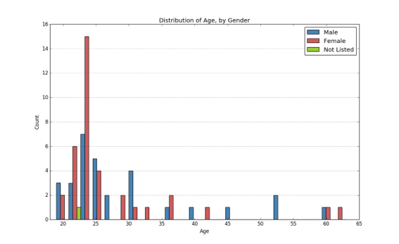

The accompanying boxplot confirms that the inter-quartile range for female participants is narrower than that of males.

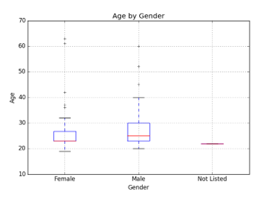

**AAQ**

Mean score on anxiety was 3.6 out of 7 (SD=0.99). This was similar for male (X=3.5, SD=1.08) and female (X=3.5, SD=0.89) participants, although female scores were generally higher – as can be seen from the following boxplot.

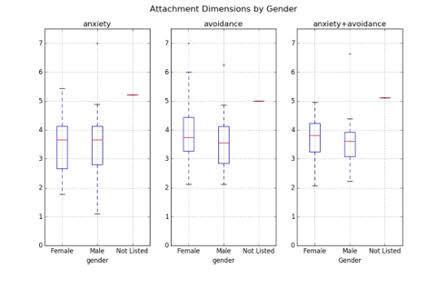

Mean score on avoidance was slightly higher, at 3.8 (SD=1.03). Male (X=3.6, SD=0.96) and female (X=3.9, SD=1.08) scores were again broadly in line with each other, although the median female score, and inter-quartile range, was higher.

Drilling-down by age and country of origin suggested a bigger group difference between male and female scores – in particular on avoidance – for those participants who were not from Italy, and aged < 35 years. However there were not enough of these participants (N=11) for any statistical inference to be reliable.

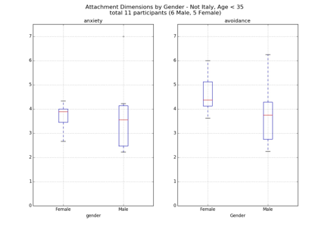

It was however instructive to look at the distribution of anxiety and avoidance amongst the Italian participants, aged < 35 (N=44). Our initial analysis suggested that these respondents comprise the most consistent sample within our data; that the distribution of anxiety and avoidance for them is consistent with the overall boxplot / interpretations, above, supports our assumption that any trends will show up without the need to group by country of origin. (To an extent, we are treating the remaining 23 participants as unsystematic noise - at least in so far as they do not correlate with any trends in the dominant sub-group.)

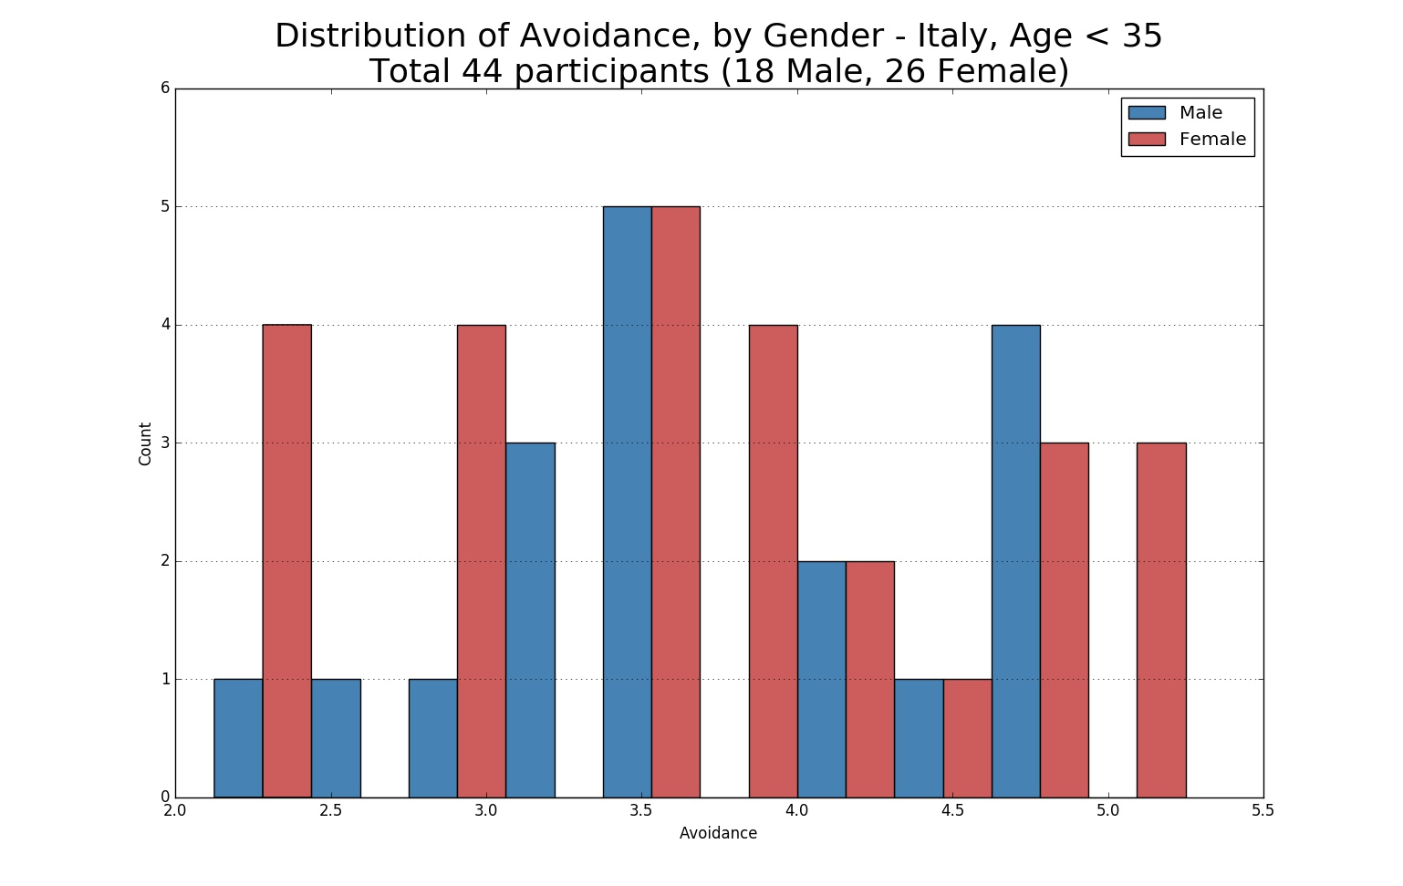

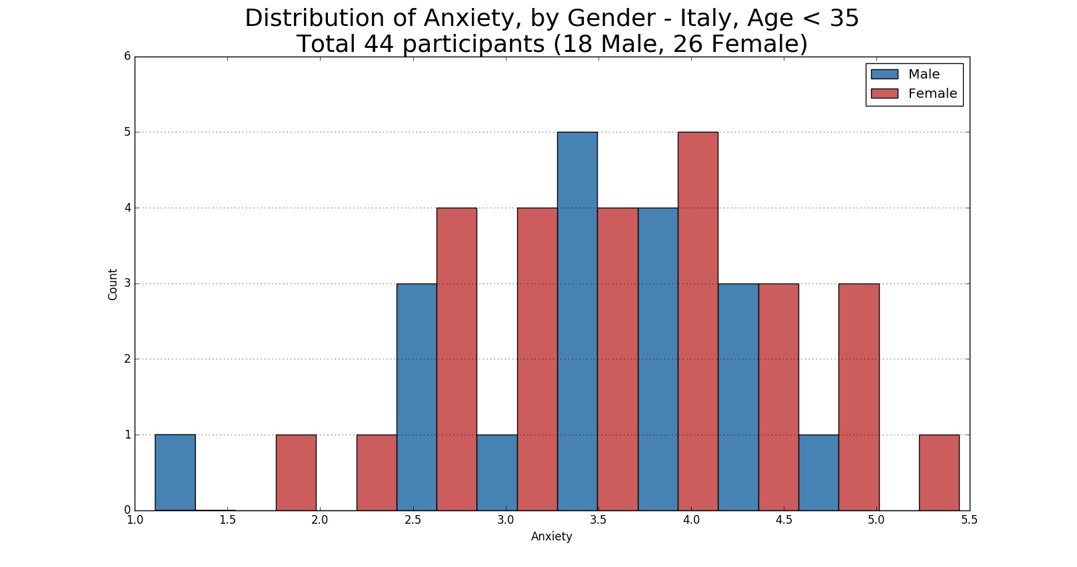

Partitioning the attachment scores into four quadrants (per the scatterplot below) seems to suggest that a majority of participants scored highly on both anxiety and attachment. (Larger circles in the plot are for the Italian participants.) This is perhaps a higher than expected level of attachment insecurity, although we would need an estimate of the distribution in the general population in order to make a comparison. 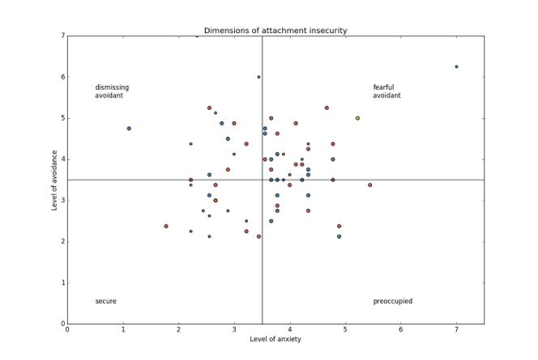

**UMI**

Our participants reported using music for primarily emotional (X=3.5, SD=0.77) purposes, vs cognitive (X=2.8, SD=0.65) and background (X=3.1, SD=0.89). Male participants reported a proportionally higher percentage of emotional usage of music (37.3%) than female participants (36.3%), and conversely female participants reported a proportionally higher usage of music for background (34.2% vs 32.4%) - as can be seen in the pie charts below. Boxplots by gender show the same directional differences in terms of median score. Range of scores is also greater for female participants, for background uses of music. Further, the median male score for cognitive uses of music appears markedly higher than the female median score, although the overall range is similar. 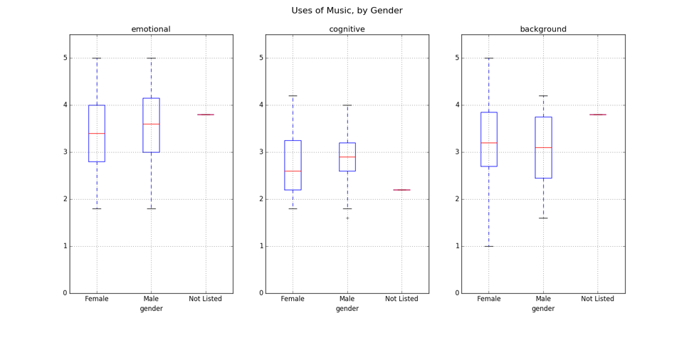

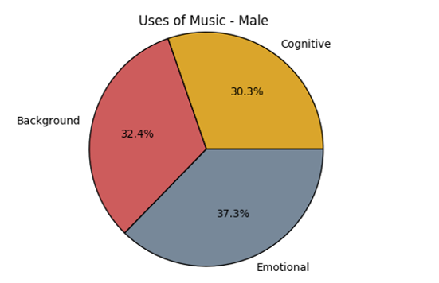 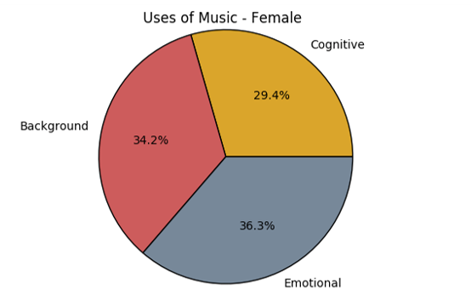

**Correlations**

We manually looked for correlations between age, level of attachment insecurity, and uses of music, by plotting a scatter matrix (below). We did not see any evidence of a relationship between age and any other measure; nor did we see any obvious relationship between level of attachment insecurity and usage of music. The most promising candidate seemed to be between level of attachment anxiety and background usage of music, and so we performed a (least squares) linear regression - which reported a correlation of r=0.26 (p < 0.034). This was found to be stronger (N=26, r=0.49, p=0.010) for female Italian participants aged < 35 years.

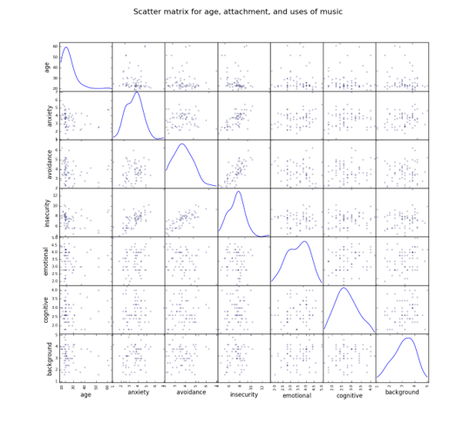

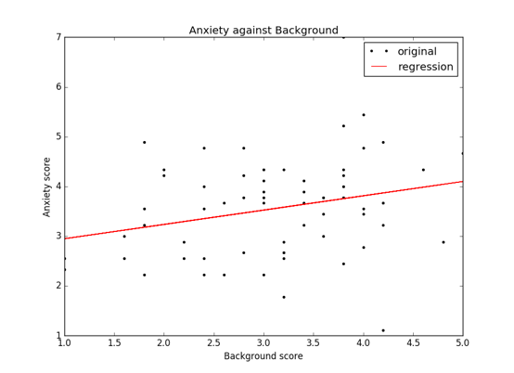

**Conclusion**

Although we found some support for a relationship between level of attachment insecurity and usage of music, we did not find any strong correlations. Possible interpretations of this include the following:

* There is no relationship.
* We did not have enough participants.
* Our sample was not representative.
* AAQ is not a suitable questionnaire.
* UOM is not a suitable questionnaire.
* Self report measures, generally, are not suitable.

In terms of the last point, a more suitable method may be an open (or semi-structured) interview, or group session. During the session, answers could be recorded and then later transcribed / scored by an evaluator.

**References**

Bartholomew, K. (1990). Avoidance of intimacy: An attachment perspective. *Journal of Social and Personal Relationships, 7*, 147–178.

Chamorro‐Premuzic, T. & Furnham, A. (2007). "Personality and music: Can traits explain how people use music in everyday life?." *British Journal of Psychology 98.2*: 175-185.

Fonagy, P., Gergely, G., Jurist, E. & Target, M (2002). *Affect regulation, mentalization, and the development of the self*. New York: Other Press.

Mikulincer, M., & Shaver, P. R. (2010). *Attachment in adulthood: Structure, dynamics, and change*. New York: Guilford Press.

Simpson, J. A., Rholes, S. W., & Phillips, D. (1996). Conflict in close relationships: An  
attachment perspective. *Journal of Personality and Social Psychology, 71*, 899–914.